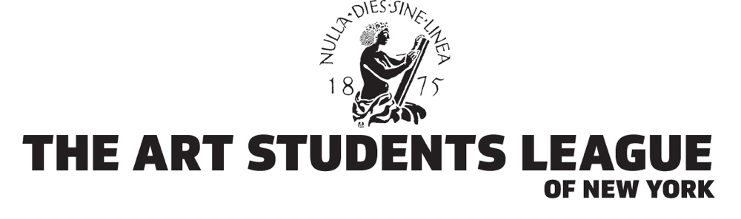
Board of Control Questionnaire
Please email completed form |  |  | Date:
To Anastasi Gudko: | agudko@artstudentsleague.org
Full Name:
Primary Address:
City, State, Zip:
Email Address:
Home Phone:
Work Phone:
Cell Phone:
Other Phone:
Other Contact Info:
Summer/Country Address, etc
Please check all that apply
Current Student? |  |  | Full or Part Time? |  |  | Since:
Current Member? |  |  | Note: You must be a member in good standing to be  considered for nomination to the Board of Control |  |  | Since:
Current Employment:
How did you become interested in serving on the BoC?

Date: |  |  | BoC Questionnaire – page 2 Name:
Board Activities in which you are interested:
Please check all that apply |  |  | My Experience is as follows:
Finance/Investment
Law
Human Resources
Computer Systems
Building Projects
Fundraising
Events
Public Relations
Advertising
Writing/Editing
Non-Profit Management
Other:

Do you have previous board experience? Where?

PLEASE ALSO EMAIL A COPY OF YOUR RESUME WITH THIS QUESTIONNAIRE — THANK YOU!

